Ubuntu Server
AI used : Gemini by Google
Prompt used : Make a security script for ubuntu server
I just made one attempt, and I type the script it worked very well.

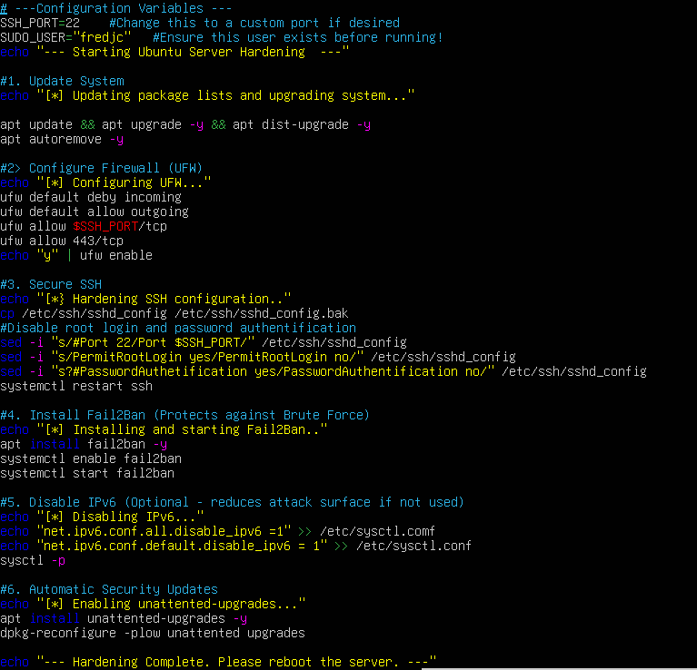
Screenshort of the Security Script provide by AI.

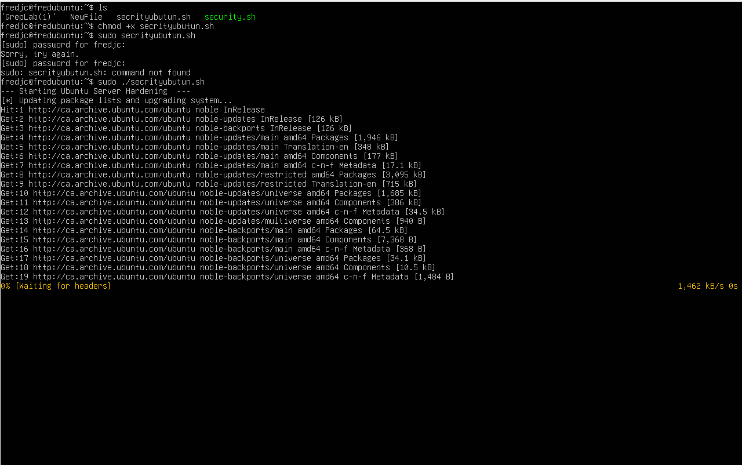
After writing the script I used command chmod +x secrityubutun.sh and sudo ./Secrityubutun.sh to make it run

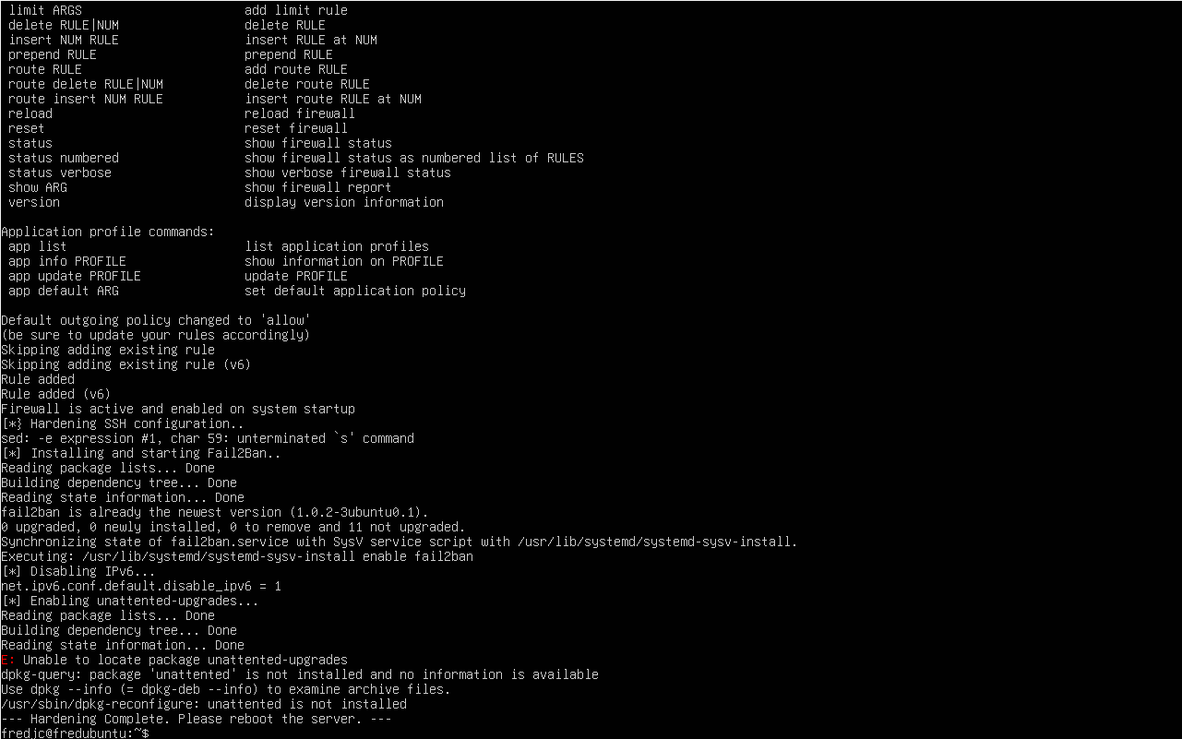
The process is complete and successful

Right now we will have to test fail2ban, firewall and ssh to see if some modifications are needed.

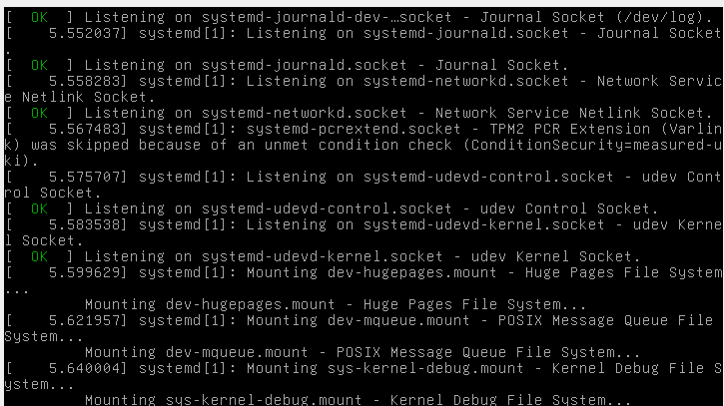
I used sudo reboot command to reboot the virtual machine ubuntu server
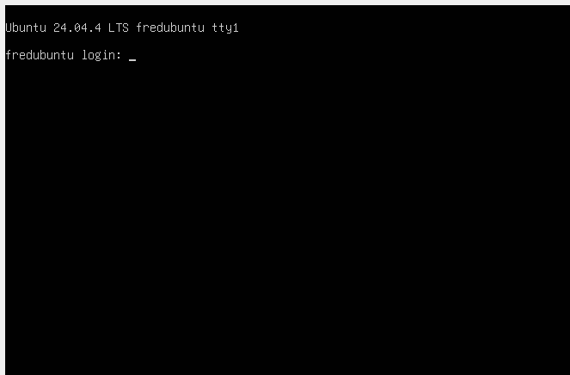
The reboot is complete and asks me to enter my login username and password

Verify firewalls
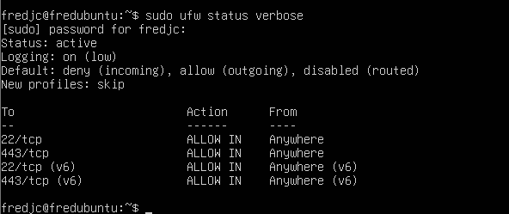
I used the command sudo ufw status verbose to verify if firewalls work well. According to these screenshots it works. It is on and blocking incoming connections while allowing outgoing traffic. It allows SSH (port 22) and HTTPS (port 443) from anywhere so the server can be accessed and used securely.
Verify Fail2ban
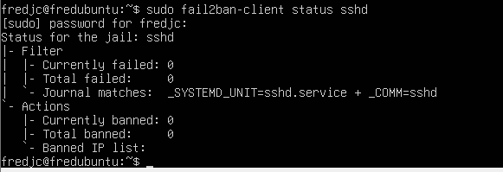
Fail2Ban is running for the SSH service and is monitoring login attempts. There are currently no failed attempts, and no IP addresses have been banned. This means no suspicious activity has been detected at the moment. I used the command sudo fail2ban-client status sshd.

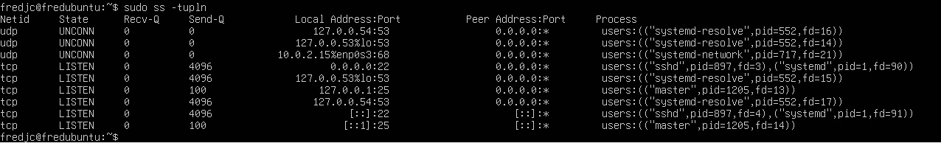
The command sudo ss -tupln shows the network ports currently in use on the system. SSH is listening port 22, and other services are also active. This means the server is running essential network services and is ready to accept SSH connections.

AI conversation summary including AI code provided
make a security script for ubuntu server
Securing an Ubuntu server requires a multi-layered approach. While "security" is a broad term, most administrators start with a Hardening Script to automate the essentials: updating the system, configuring a firewall, managing users, and tightening SSH.
Below is a comprehensive Bash script designed for a fresh Ubuntu installation.

Ubuntu Server Hardening Script
Warning: Run this script as root or with sudo. Review the SSH configuration section carefully—if you use password-based login and the script disables it, you could be locked out.
Bash
#!/bin/bash

# --- Configuration Variables ---
SSH_PORT=22 # Change this to a custom port if desired
SUDO_USER="your_username" # Ensure this user exists before running!

echo "--- Starting Ubuntu Server Hardening ---"

# 1. Update System
echo "[*] Updating package lists and upgrading system..."
apt update && apt upgrade -y && apt dist-upgrade -y
apt autoremove -y

# 2. Configure Firewall (UFW)
echo "[*] Configuring UFW..."
ufw default deny incoming
ufw default allow outgoing
ufw allow $SSH_PORT/tcp
ufw allow 80/tcp
ufw allow 443/tcp
echo "y" | ufw enable

# 3. Secure SSH
echo "[*] Hardening SSH configuration..."
cp /etc/ssh/sshd_config /etc/ssh/sshd_config.bak
# Disable root login and password authentication
sed -i "s/#Port 22/Port $SSH_PORT/" /etc/ssh/sshd_config
sed -i "s/PermitRootLogin yes/PermitRootLogin no/" /etc/ssh/sshd_config
sed -i "s/#PasswordAuthentication yes/PasswordAuthentication no/" /etc/ssh/sshd_config
systemctl restart ssh

# 4. Install Fail2Ban (Protects against Brute Force)
echo "[*] Installing and starting Fail2Ban..."
apt install fail2ban -y
systemctl enable fail2ban
systemctl start fail2ban

# 5. Disable IPv6 (Optional - reduces attack surface if not used)
echo "[*] Disabling IPv6..."
echo "net.ipv6.conf.all.disable_ipv6 = 1" >> /etc/sysctl.conf
echo "net.ipv6.conf.default.disable_ipv6 = 1" >> /etc/sysctl.conf
sysctl -p

# 6. Automatic Security Updates
echo "[*] Enabling unattended-upgrades..."
apt install unattended-upgrades -y
dpkg-reconfigure -plow unattended-upgrades

echo "--- Hardening Complete. Please reboot the server. ---"

Key Security Components Explained
Component | Purpose
UFW (Uncomplicated Firewall) | Blocks all incoming traffic by default, only opening the doors you specifically need (SSH, HTTP).
Fail2Ban | Monitors log files for failed login attempts and temporarily bans the IP addresses of potential attackers.
SSH Hardening | Disabling PermitRootLogin prevents attackers from targeting the root account directly. Disabling passwords forces the use of SSH Keys, which are significantly more secure.
Unattended Upgrades | Ensures that security patches are installed automatically as soon as they are released by Canonical.

Post-Script Checklist
- SSH Keys: Ensure you have copied your public key to the server (ssh-copy-id) before disabling password authentication in the script.
- Audit Logs: Regularly check /var/log/auth.log for suspicious login activity.
- Kernel Hardening: For high-security environments, consider installing lynis, an auditing tool that provides a "security score" and specific hardening tips:
  - sudo apt install lynis && sudo lynis audit system
What specific services (like Nginx, Docker, or a Database) are you planning to run on this server? I can help you tailor the firewall rules and permissions for those specifically.

